PROJECT: YOUTUBE CONTENT CREATION STUDIO
COURSE CODE: DICT 111 COURSE: FUNDAMENTALS OF ICT
GROUP 5
MEMBERS: Lemuta Lemmone-26-0214
Ludphin Nyambura-26-0478
Jeremiah Mulenga-26-0137
Vallerie Kagiri-26-0766
Tresor Josue-26-0631
Lennox Maitha-25 1293

1. Business Description
Business Name: Buzzframe Studio
Type: YouTube Content Creation Studio (small business)
Overview: Buzzframe Studios produces high-quality video content for YouTube, including tech reviews, educational videos, podcasts, and lifestyle vlogs. The business operates both in-person and online, with a small team of creators, editors, and marketing staff collaborating to plan, record, edit, and publish engaging video content consistently.
Operations and Services:
Content creation: Scripting, filming, and editing videos for YouTube and related social media platforms.
Post-production: Video editing, color grading, sound mixing, and effects.
Digital marketing services: SEO optimization, analytics tracking, and audience engagement across YouTube and other social platforms.
Live streaming and podcasting: Hosting webinars, interviews, and live interactive events.
Users:
Internal users: Content creators, video editors, sound engineers, social media managers, and administrative staff.
External users: Clients or partners (brands for sponsorships), viewers, and subscribers who engage with the content online.
2. Reason for Selection
This business was chosen because a YouTube content creation studio is a modern, technology-driven enterprise that depends heavily on digital systems. It illustrates how core computing concepts—from hardware like high-performance PCs and cameras to software for editing, cloud storage, and cybersecurity—integrate to enable efficient media production and distribution. It also reflects a rapidly growing real-world industry, making it both relevant and practical.
Software Requirements
Software is important in a YouTube content creation studio because it controls the hardware, enables content production, supports communication and business operations.
- System Software (Operating Systems)
Operating Systems to be used: Microsoft Windows (Windows 10/11)
macOS
Windows is affordable and widely available in Kenya while macOS is used for its strong performance in video editing.
How They Support Business Operations.
They manage hardware like CPU, memory, storage, and graphics cards.
They allow installation and running of editing software.
They provide user interface for staff to interact with computers.
They support file management (saving, copying, organizing videos).
They ensure compatibility with the most professional editing tools.
- B. Application Software (Business-Specific)
- Video Editing Software
- Adobe Premiere Pro
- DaVinci Resolve
- DaVinci Resolve is popular in Kenya because it has a free version which reduces costs. Professional studios in Nairobi often use Adobe Premiere Pro for advanced editing.
How They Support Operations
- They edit raw footage into professional videos.
- They add transitions, effects, subtitles and color correction.
- They export videos in formats suitable for YouTube.
- It is free and lightweight making it ideal for the small business.
How It Supports Operations
- It removes background noise (important in urban environments).
- It adjusts sound levels and improves clarity
- It edits voiceovers and podcasts
Graphic Design Software (Thumbnails & Branding)
- Adobe Photoshop
- Canva
Many creators use Canva because:
- It works well on low-spec devices
- It is easy to learn
- It has free templates
- How They Support Operations
- They create thumbnails (very important for YouTube clicks).
- They design logos, banners, and social media graphics.
- Content Upload & Management Tools
Supports Operations
- It uploads and publishes videos.
- It monitors views, subscribers and revenue.
- It manages comments and audience engagement.
Productivity & Collaboration Software
- Google Workspace
Google Workspace is a good choice because:
- It works well with limited internet bandwidth.
- It allows remote collaboration (useful for freelancers).
- Microsoft Office
How They Support Operations
- They are used for script writing (Google Docs / Word).
- They are used for budget tracking (Excel / Sheets).
- They are used for team communication and planning
- Google Drive / Dropbox
How They Support Operations
- They store large video files safely.
- They share files between team members.
- They provide backup in case of hardware failure.

Content Creation Hardware (Recording Stage)
This focuses on recording equipment and explains why each one was selected:
- Camera (DSLR or Mirrorless)
It is used in recording high quality videos
Mirrorless/DSLR cameras provide better video quality than smartphones, especially in lighting and focus. They are more expensive but give professional results, which is important for growing a YouTube channel.
- Tripod
Keeps the camera stable.
It is very affordable but makes a big difference in video quality by preventing shaky footage, making it a cost-effective tool.
- Microphone (External Mic)
Captures clear audio.
Built-in camera microphones are usually poor quality, so an external mic is necessary for professional sound, which improves viewer retention.
- Lighting Equipment (Ring light
Improves brightness and reduces shadows.
Natural lighting is unreliable, so artificial lighting ensures consistent quality. Ring lights are also relatively affordable and widely used by content creators
- Green Screen
Allows background editing.
It is a low-cost way to create different environments without needing multiple physical locations, saving money in the long run.

After recording the content using these devices, the next stage involves editing, storing, and preparing the video for upload.

Processing & Support Hardware (Post-Production Stage)

  - High-Performance Computer (Editing PC)
This is the main device used for editing videos and putting everything together. Why chosen: Video editing requires high processing power. A strong PC reduces editing time and improves efficiency, making it worth the investment.
  - Headphones
Used to monitor audio.
👉 Why chosen: Speakers may not reveal small audio issues, so headphones provide more accurate sound checking at a low cost.
  - External Hard Drive
Used to store video files and keep backup
Why chosen: Video files are usually very large. An external hard drive gives extra space and helps secure your work.
  - Internet Router
Provides internet connection.
Why chosen: A stable router ensures fast uploads and smooth streaming, which is essential for online content creation.
  - UPS (Uninterruptible Power Supply)
Provides backup power.
Why chosen: Power outages can damage equipment or cause data loss. A UPS protects the system, making it a smart long-term investment.
  - Backup System (Cloud Storage)
Used to store videos online.
Why chosen; It acts as a safety net. Even if the computer fails, the files are still safe and can be accessed anytime

  - Graphics Card(GPU)
Helps the computer handle video editing tasks better.
Why Chosen: It makes editing smoother and speeds up rendering, especially when working with high quality videos.

IN CONCLUSION:
All these tools work together to make editing easier, faster, and more professional, helping create high quality YouTube content.

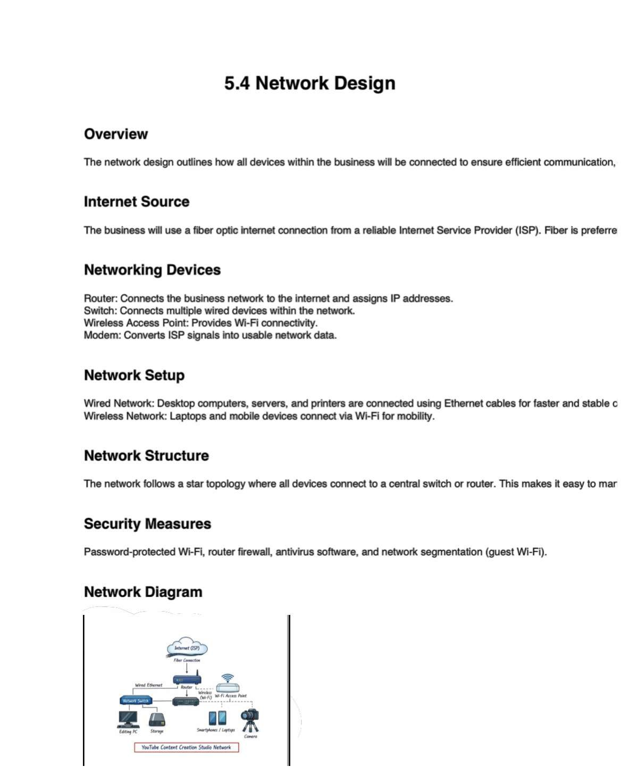

5.5 Data Management and Security (YouTube Content Creation)
Creating YouTube content produces a lot of files—videos, thumbnails, scripts, and analytics. If these aren’t handled properly, you could lose your work or even risk being hacked. Good data management and security are therefore essential. Data Storage
High-resolution videos and editing files take up a lot of space. To manage this:
- Local storage: Keep files on your computer or external drives (hard drives or SSDs). This allows quick access while editing and keeps things running smoothly.
- Cloud storage: Use Google Drive or Dropbox to store a backup online. This way, you can access files from anywhere and your work is safe even if your device fails.
Tip: Combining local and cloud storage gives you speed and security at the same time. Backup Strategy
Backing up your work is critical:
- Weekly backups: Regularly save general files.
- Immediate backups: Back up important projects or finished videos right after completion.
- Dual backup system:
o External backup: Keep a copy on an external drive offline. o Cloud backup: Upload a second copy online for extra safety.
Organize your files in labeled folders like Raw Footage, Edited Videos, Thumbnails, Scripts so you can find what you need quickly. Security Measures
Protecting your accounts and files is just as important as storing them:
- Password policies: Use strong, unique passwords with letters, numbers, and symbols. Turn on two-factor authentication for extra security.
- Antivirus & firewall: Keep antivirus software updated and enable a firewall to block threats. Also, keep your system and apps updated.
- User access control: Only give access to trusted people. Assign permissions based on roles and never share login info openly. Always log out on shared devices.

Conclusion
By combining local and cloud storage, backing up files regularly, and using strong security measures, YouTube creators can protect their work, stay productive, and avoid setbacks. Good data management and security make content creation smoother and safer.

